**JAVA Interview Questions**

**Comparable vs Comparator in Java**

In this example we have two classes Laptop and Runner. In laptop class we will create getter setter, two string method and constructor.

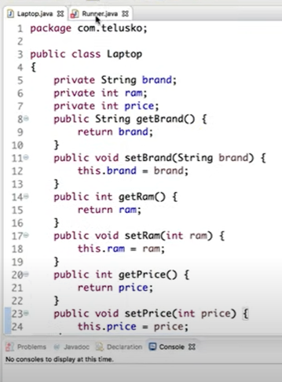

In Runner class we will create a list of laptop.

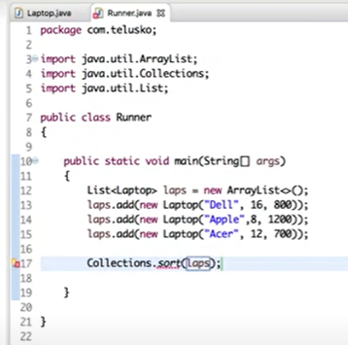

Sort is not working here because sort will sort the values on the basis of some parameters ex: we have 5 value of integer in a list.

For list of laptop we have not specified for which parameter we want to sort the values. If you want sort the list of laptop you need to implement laptop class with comparable.

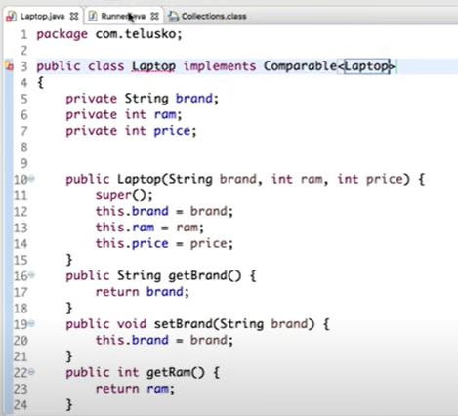

In compare interface we have a method of **compareTo** to sort the values.

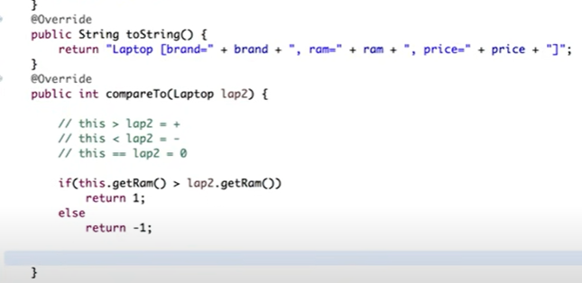

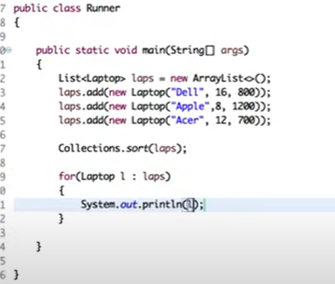

**What is comparator?**

We have two situations for comparator:

First situation you got a class but this class is not implemented with comparable interface.

Sort method also take two parameters

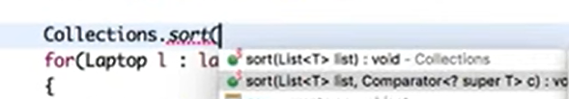

In second situation even if you have a class with implemented comparable interface and you want to sort the values with other parameters

Point : watch a video anonymous in a class

We will instantiate a interface by creating an anonymous class.

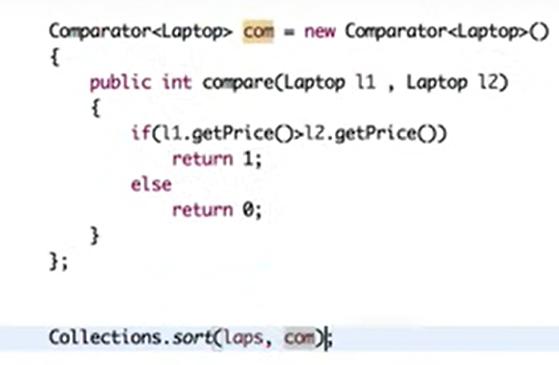

<https://www.javatpoint.com/difference-between-comparable-and-comparator>

# How does HashMap internally works

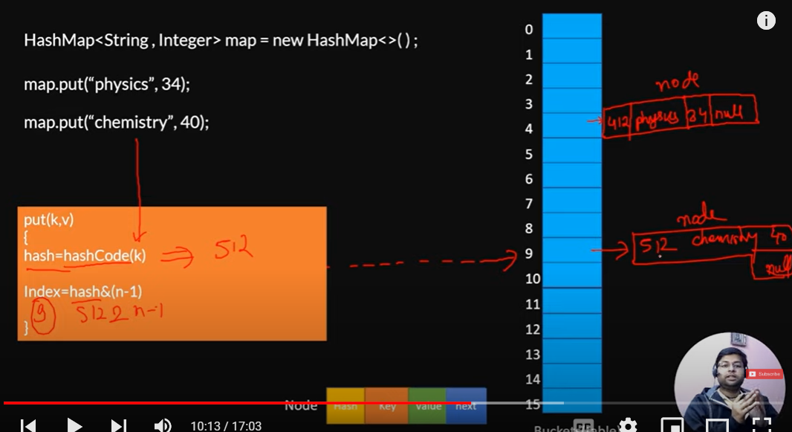

Hash map stores value in linked list manner.

Hash collision means pehlay sai jo hash calculate hoa hai wo wapis sai ajaye usay kehtay hai hash collision.

Is scenario mai equal function lagay ga key ki base par or key same nahi hoe tw agay lag jayega wo node or pehlay waalay mai uska address store hojayega is tarah linked list banjayegi.

**Interview question:**

Agar null key oh tw first waalay bucket mai store hojayegi.

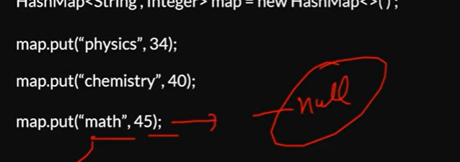

Ab aksar 1 bucket mai kaafi lambi linked banjati tw us waqt get operation mai mushkil aati is liye java8 mai enhancement aye thi.

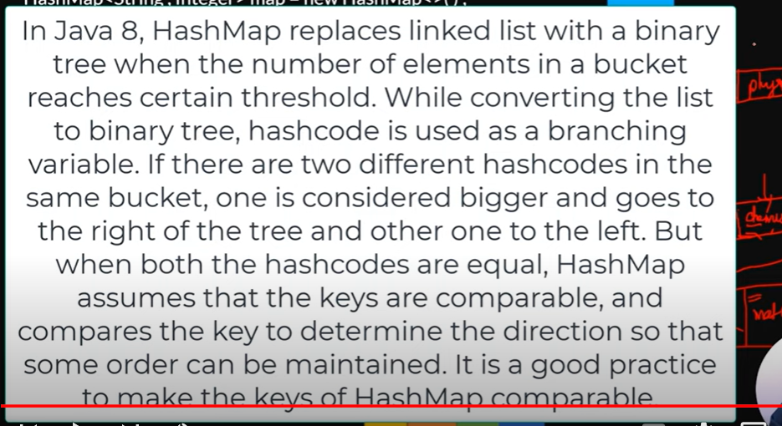

# HashMap Get Operation

Get operation jab lagayengay tw wo bhi hashcode ki madad sai index find karay ga

Jab 1 bucket mai multiple nodes hongay tw tab wo waalay hash k madad sai index dekhay ga wo same hongay tw us k baad wo key match karay ga.

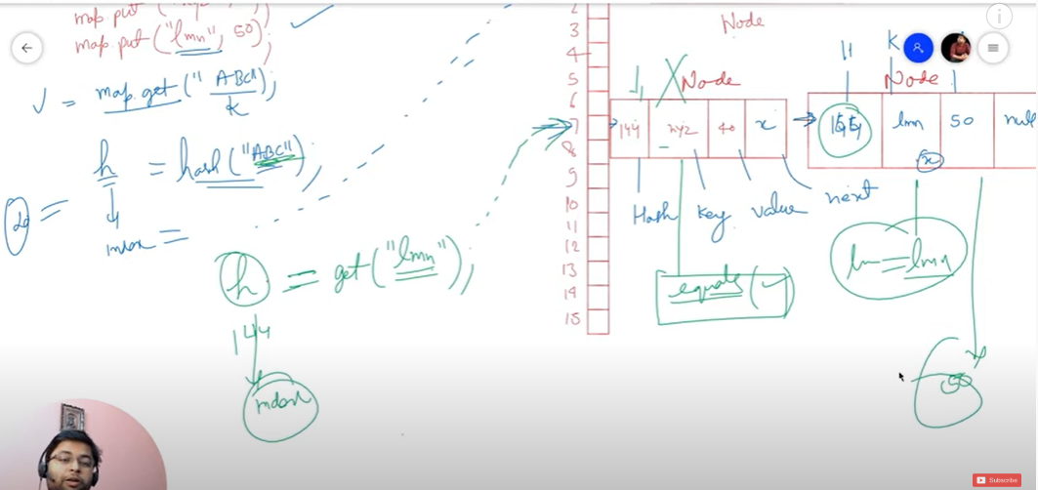

# Top 15 HashMap related Interview questions

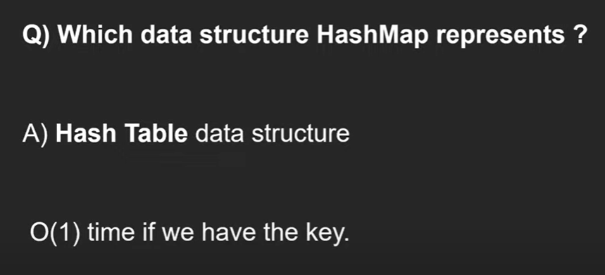

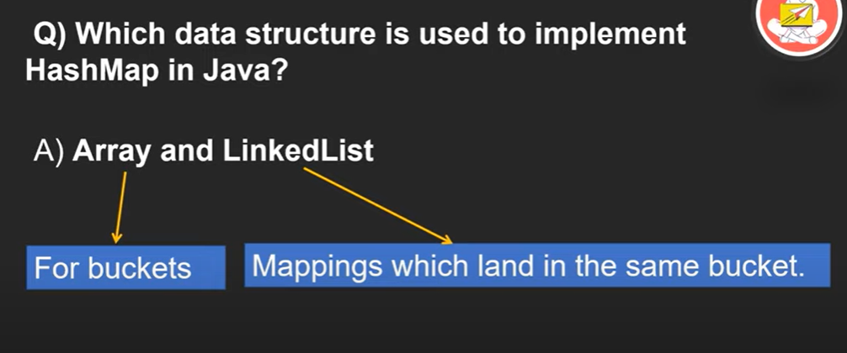

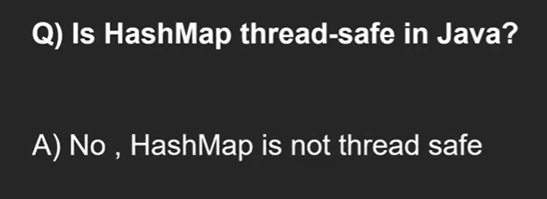

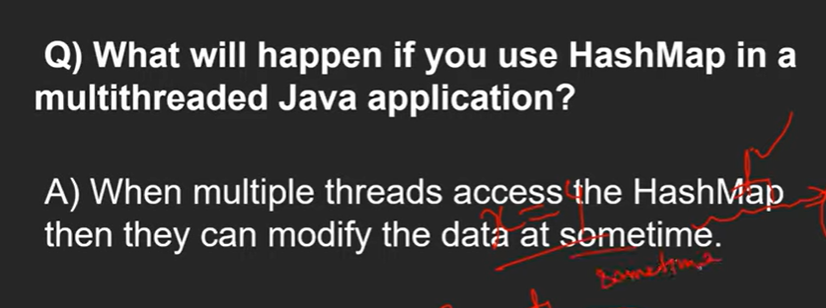

Jab application mai multiple threads ho tw us waqt hashmap use nahi karengay.

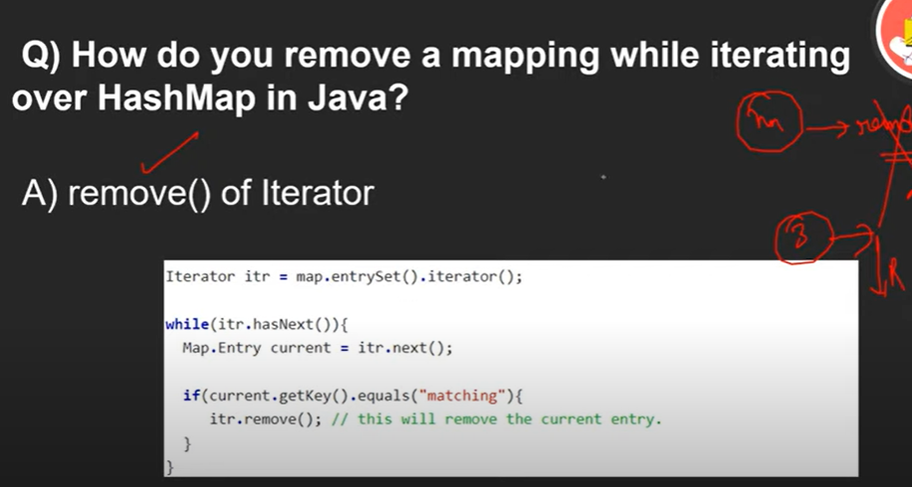

Map ka remove method nahi kaam karay ga iterate kartay hoa.

